**Date: 27-05-2025**

**INTERNSHIP LETTER**

This is to certify that **Mr. Abhishek Reddy** was working in our organization

**Ozrit Ai Solutions** as **“Digital Marketing Intern”** from **24.02.2024 to 24.05.2024**

We hereby certify that his performance was good during the tenure.

His contribution to the organization and its success will always be appreciated.

We wish him all the best in his future endeavors.

**For Ozrit Ai Solutions.**

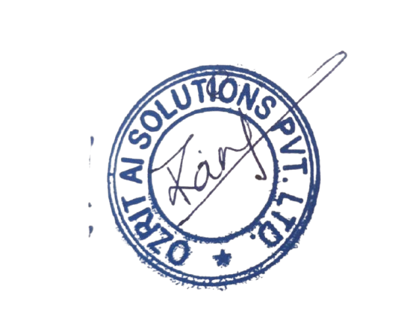

**Rani Kumari**

**HR & Admin Executive**